**ADVANCED SOFTWARE ENGINEERING**

**HIGH-LEVEL DESIGN**

**TEAM NO : 3**

**Sai Santhosh Bhattaram-100184167 , Rohith Peta – 1001966013**

**Divya Mattigunta – 1001960759 , Sirisha Mandalapu - 1001886132**

**ARCHITECTURE DESIGN**

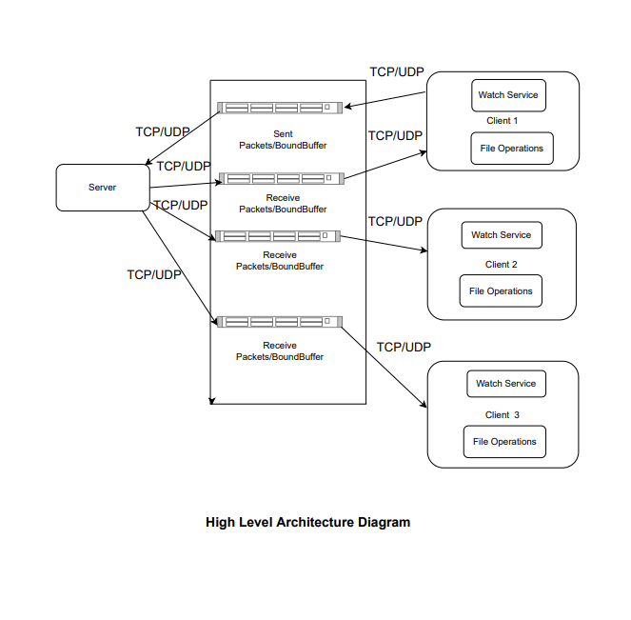

* Above architecture diagram is a high level representation of connection and working of different modules of the project.
* Clients makes connection using TCP protocol and does packet switching using UDP protocol.
* Single client watches the changes , delta sync and file sync changes to the server.
* Multiple client watches for the respective changes including synchronization and sends it to server.
* The data in the file is sent using bound buffer management to server.

**THREAD MANAGEMENT**

1. Connection Manager: Connection Manager thread is used to make connections between clients and Server using TCP Protocol
2. File Monitor watcher: File monitor watcher service thread is used to monitor the changes made to the files at client and server end
3. Packet switcher: Packet switcher thread is used for exchanging packets between clients ad server (Send/Receive).
4. File Sync: File Sync thread is used for Syncing all the changes of files between client and server and also to monitor the sync status

**PROJECT SCHEDULE**

**Major Tasks:**

* Implementing File transfer between Single Client and server
* Implementing multiple files transfer between single client and server
* Implementing watcher service to monitor the changes made to the files
* Implementing file synchronization between multiple clients and server

|  |  |
| --- | --- |
| TASKS | DEADLINES |
| SINGLE CLIENT AND SERVER | 24TH JUNE |
| WATCH SERVICES | 27TH JUNE |
| SYNCING FILES BETWEEN MULTIPLE CLIENTS AND SERVER | 30TH JUNE |
| UNIT TESTING AND WORKING ON BUGS | 3RD JULY |
| INTEGRATION TESTING AND  WORKING ON BUGS | 5th July-6th July |

* Testing and verification of all components.

**Test Plan**:

* Testing connection between clients and server
* Testing for File syncs: Following test cases to be executed :

1.Testing whether files are syncing correctly or not

2.Testing for Duplicate files while file Synchronization is happening

* Testing for concurrency:

1.Multiple clients updating the Same File

2.Checking File Integrity after concurrent Access